Deploying an app from crow-eye view means this:

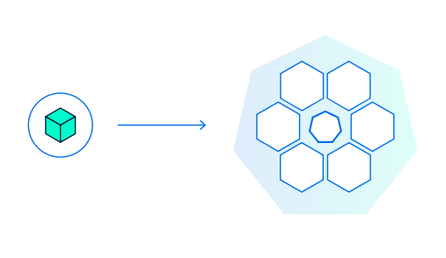

Or rather this: As we have read (Chapter#1) that deployment happens on any of the nodes….

